**PROJECT DESIGN PHASE 1-SOLUTION ARCHITECTURE**

|  |  |
| --- | --- |
| Team ID | PNT2022TMID22791 |
| Project Name | Containment Zone Alerting Application |

**INTERFACE**

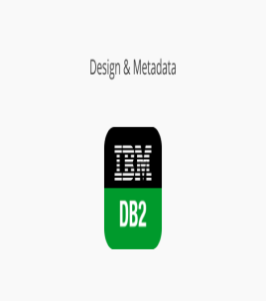

STORES THE USER INFORMATION

**USER ADMIN**

UPDATES CONTAINMENT ZONE



STORESS THE LOCATION DETAILS OF

CONTAINMENT ZONE

ALERT USE

BY ALERT

NOTIFICATION